

**User Guide**

In Admin panel you need to enable this module under

**store > configuration > BlueThink Inc > Product Quantity Dropdown**

There are few options to set Maximum Quantity value,Dropdown Type(Default Value,Quantity Increment Value,Custom Value),Show Price In Dropdown(Price Per Item,Total Price,None).

This Extention only work on Product Type Simple and Configurable.

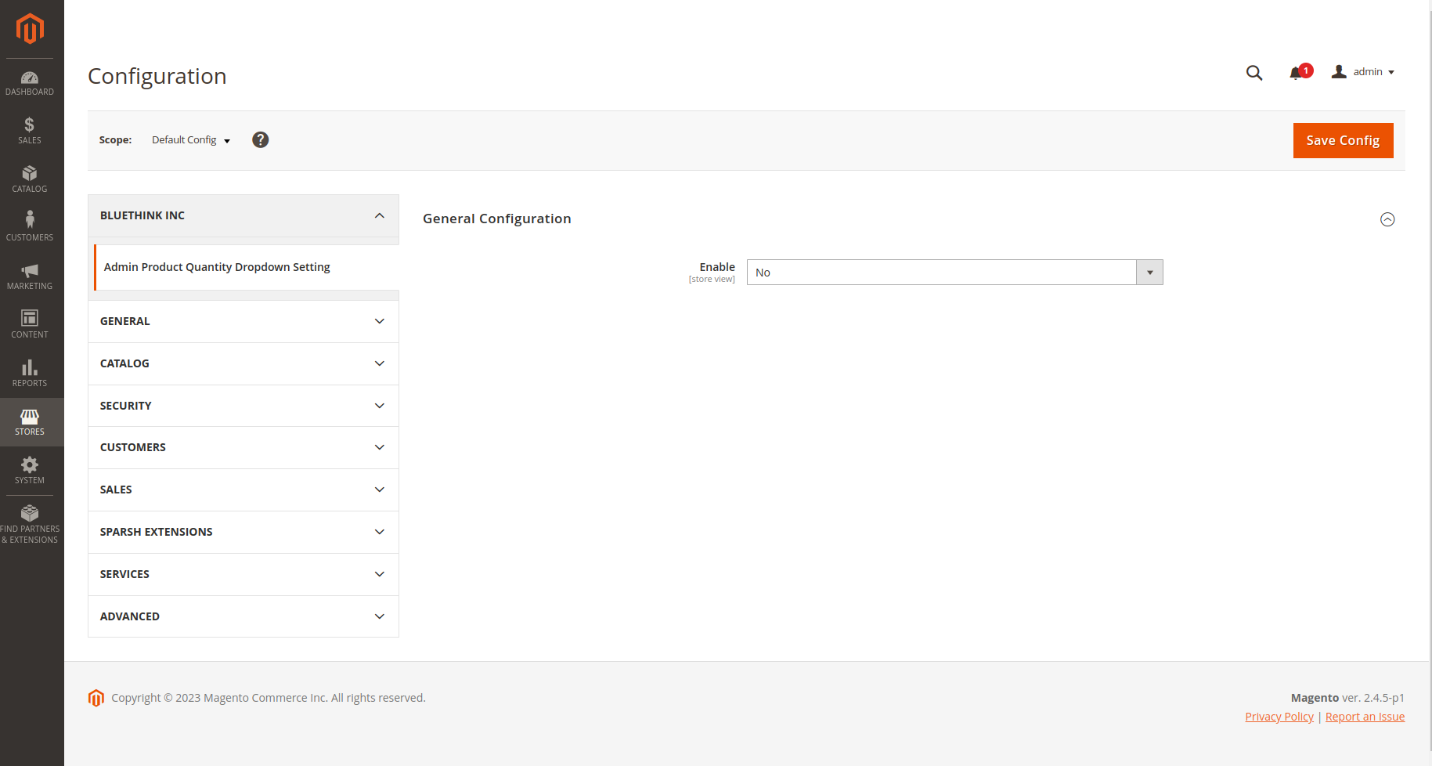Enable Option Select Yes Option and save config.

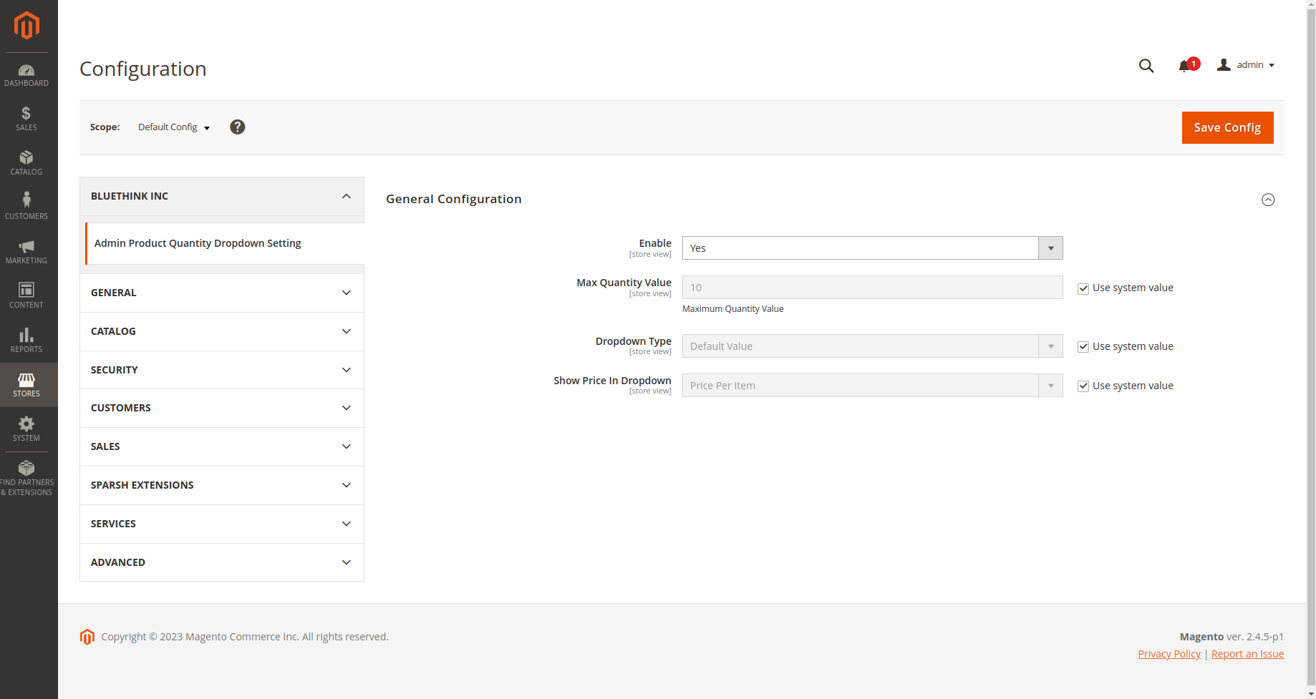

Product quantity dropdown look like this.

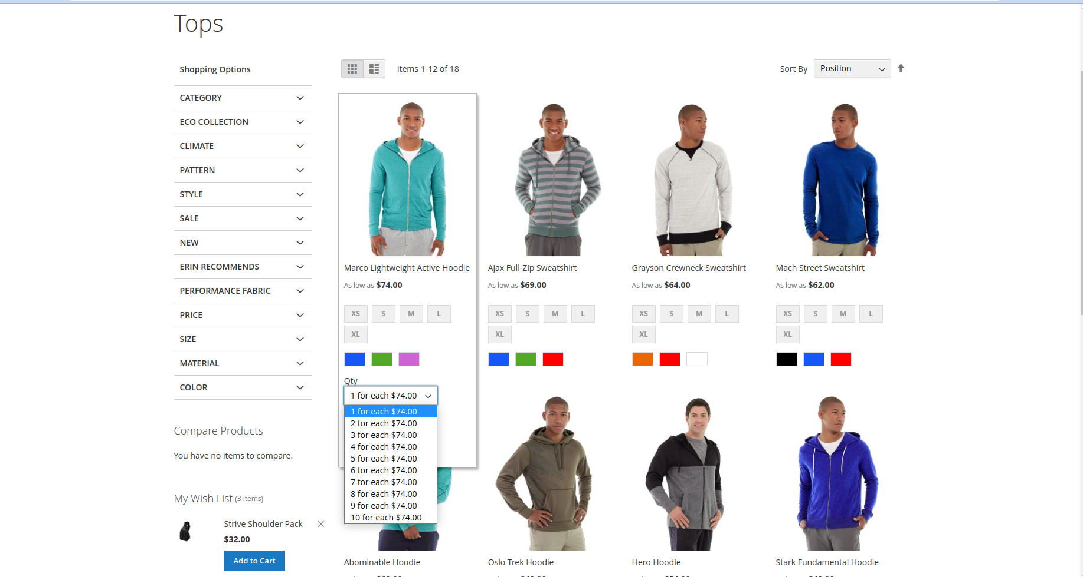

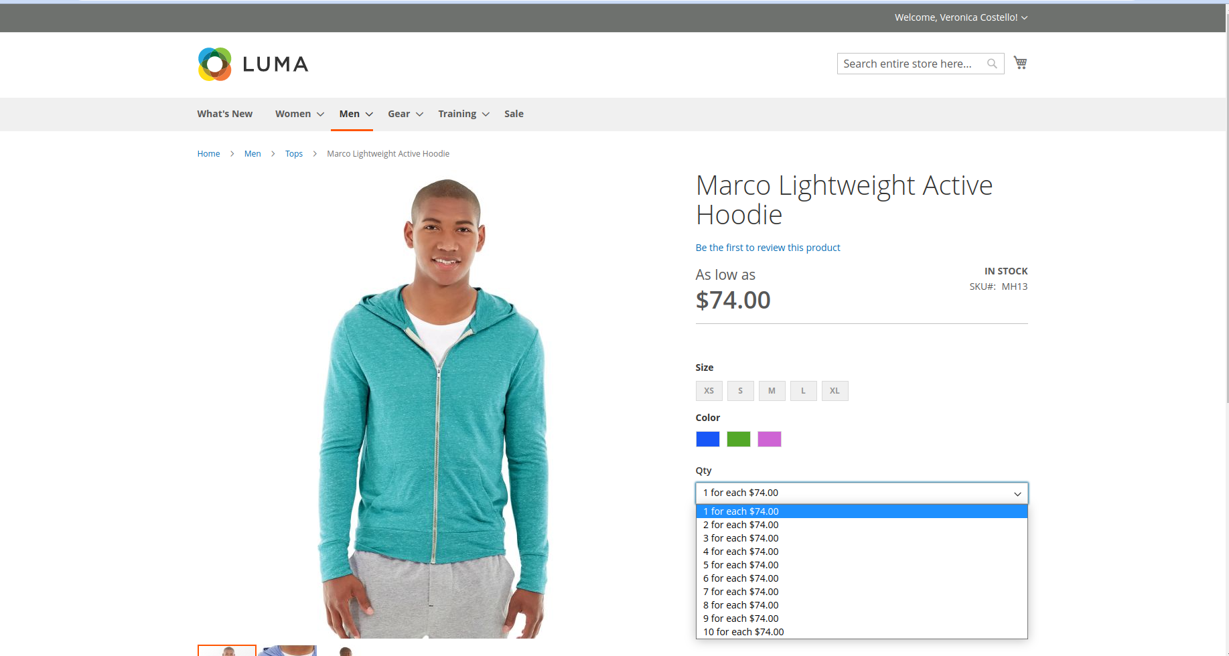

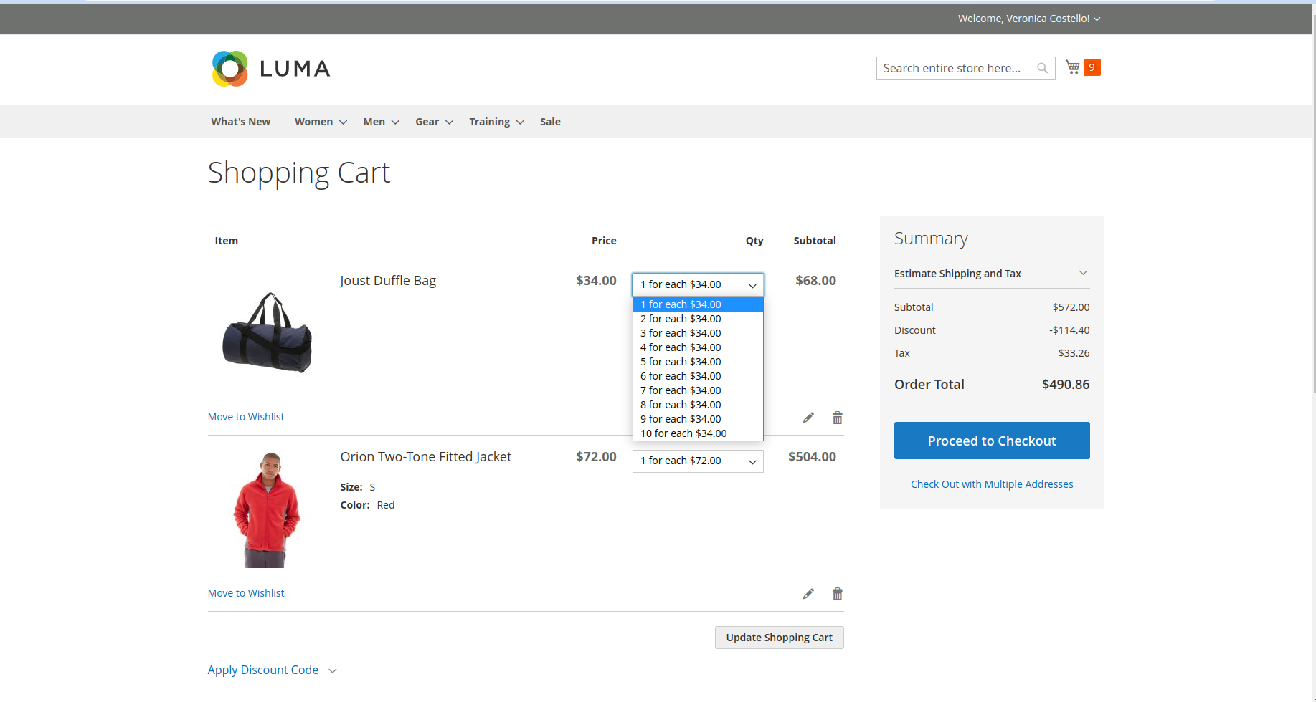

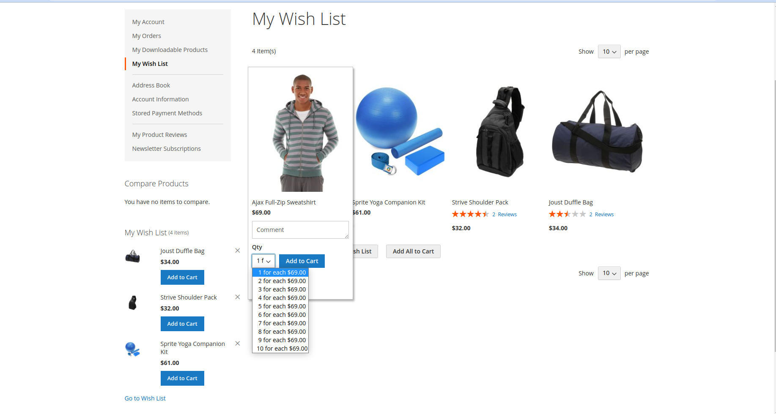I have Set Max Quantity Value 5 and save config.

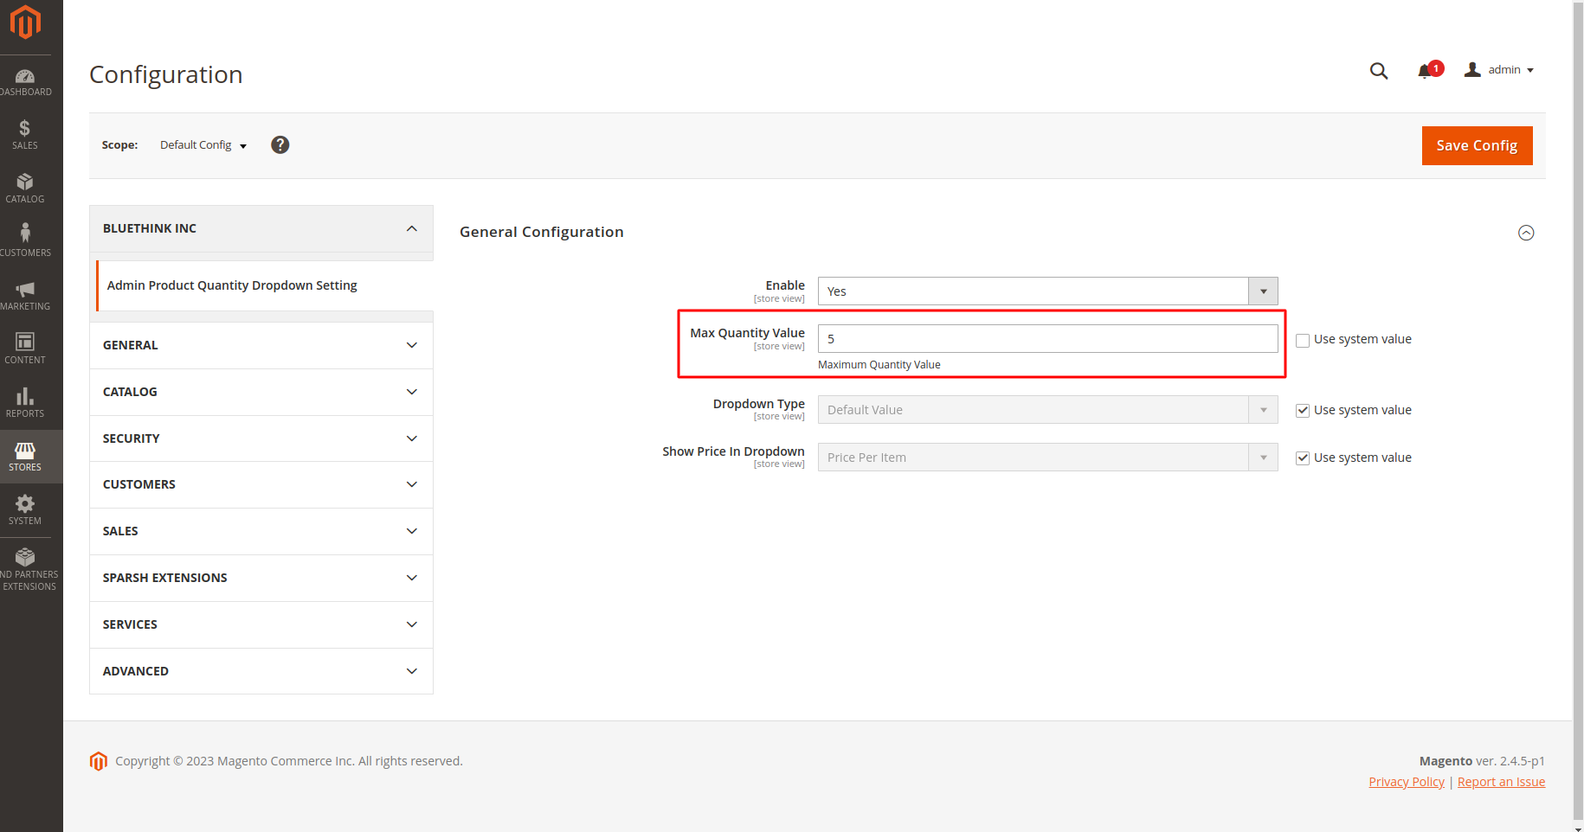Product quantity dropdown look like this.

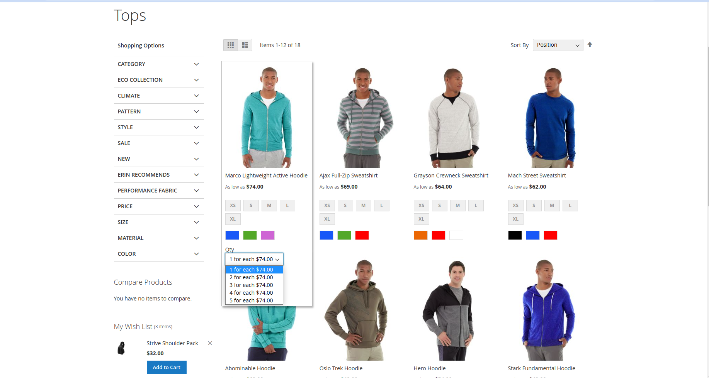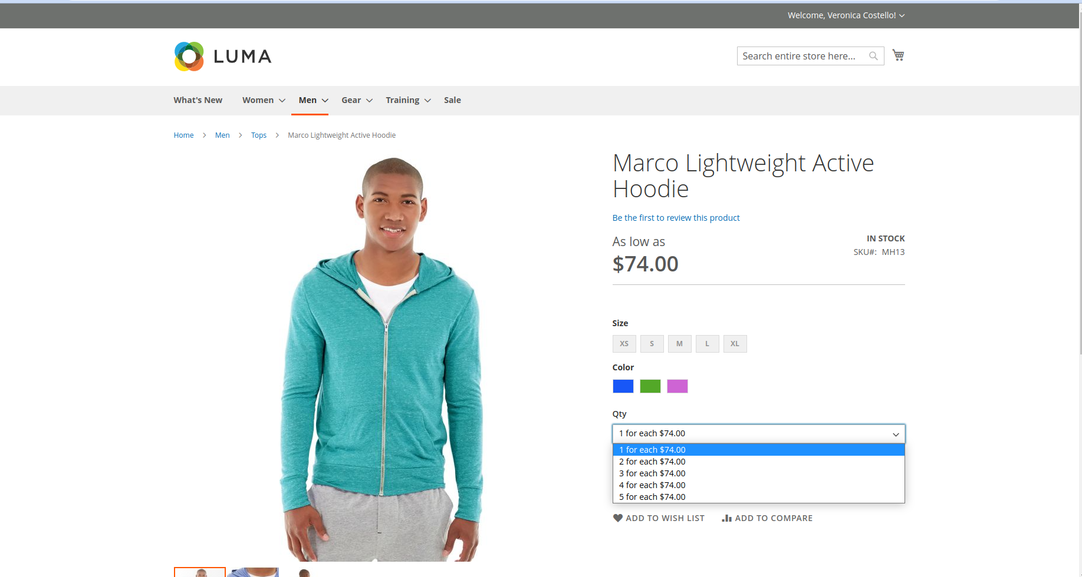

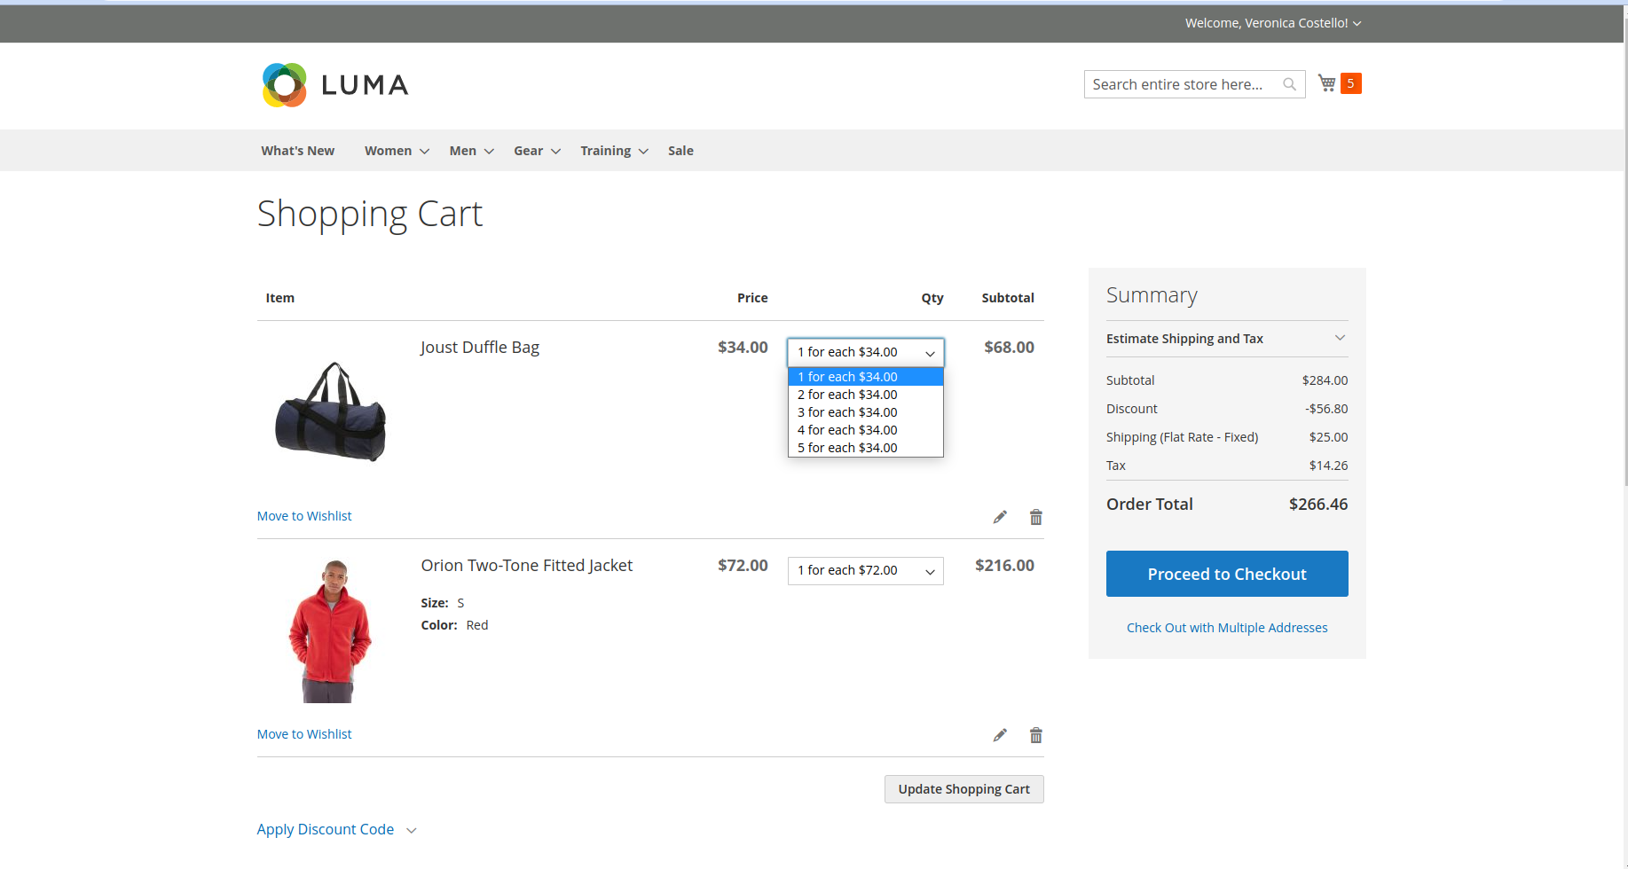

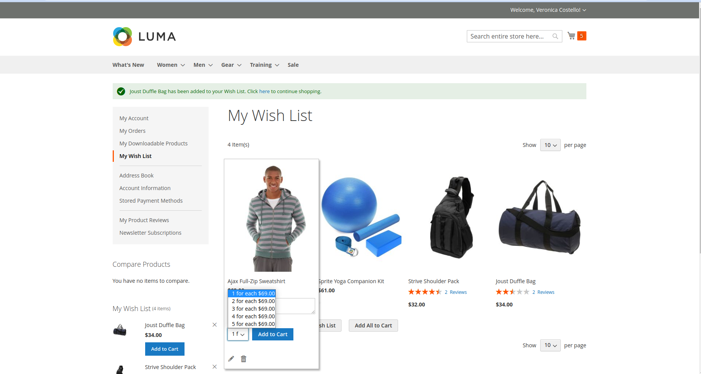

I have select Dropdown Type ‘Quantity Increment Value’ and

Start Increment value set input field 2 and Increment Value set input field 2 and save config.

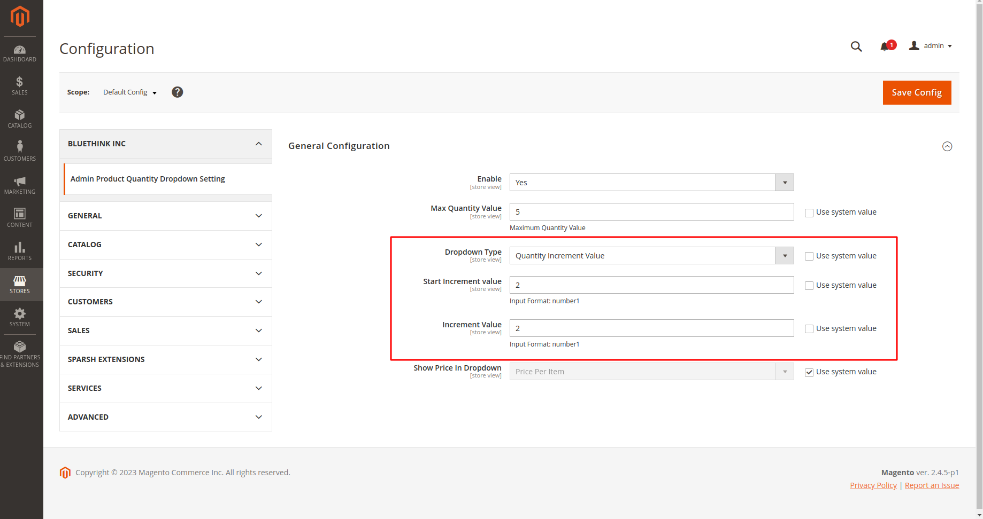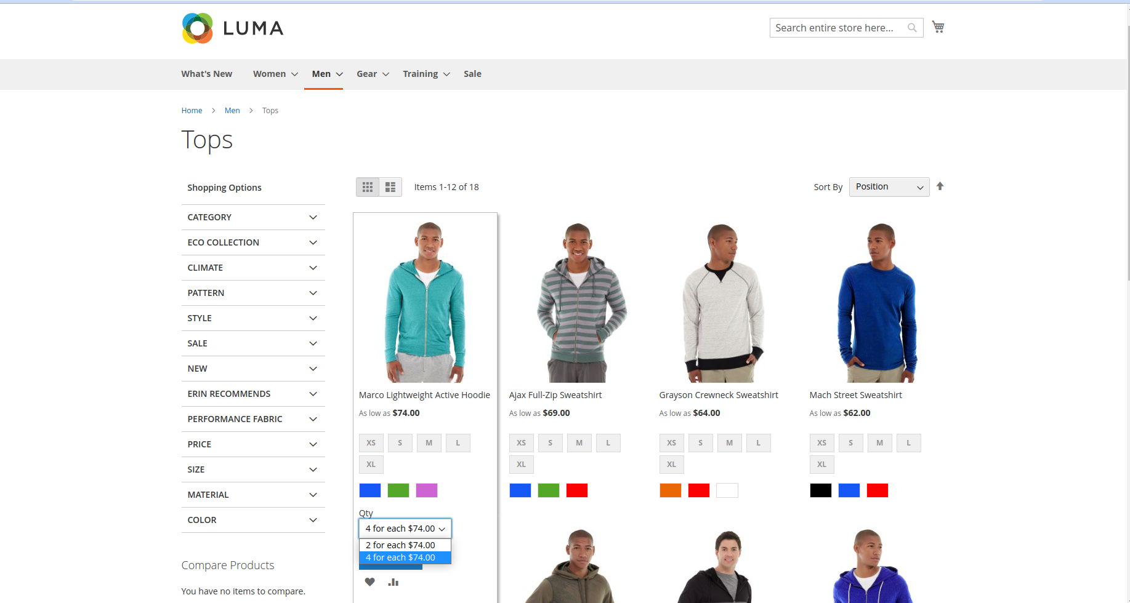

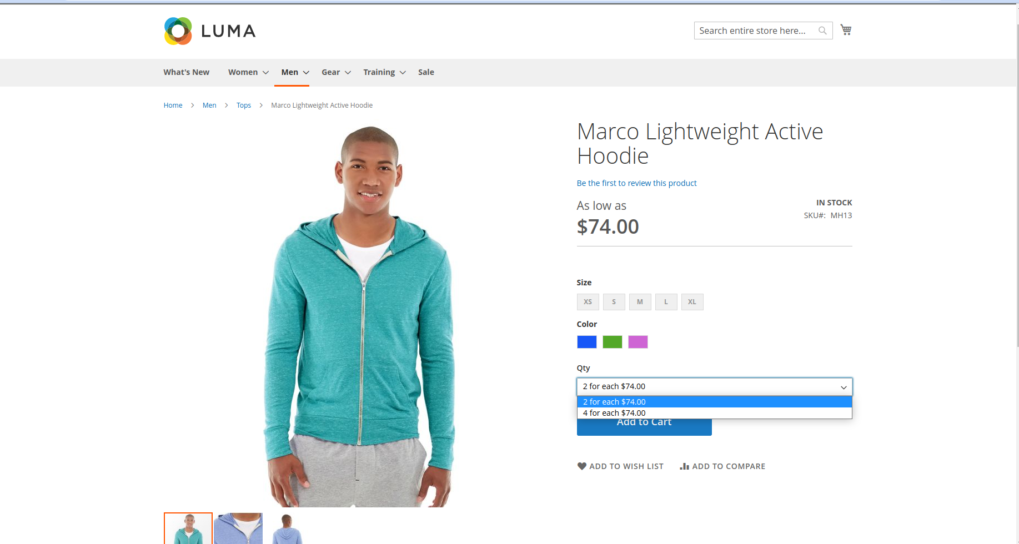

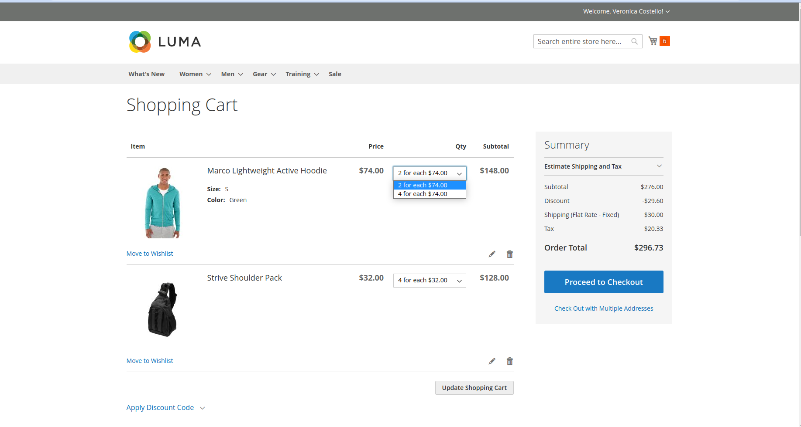

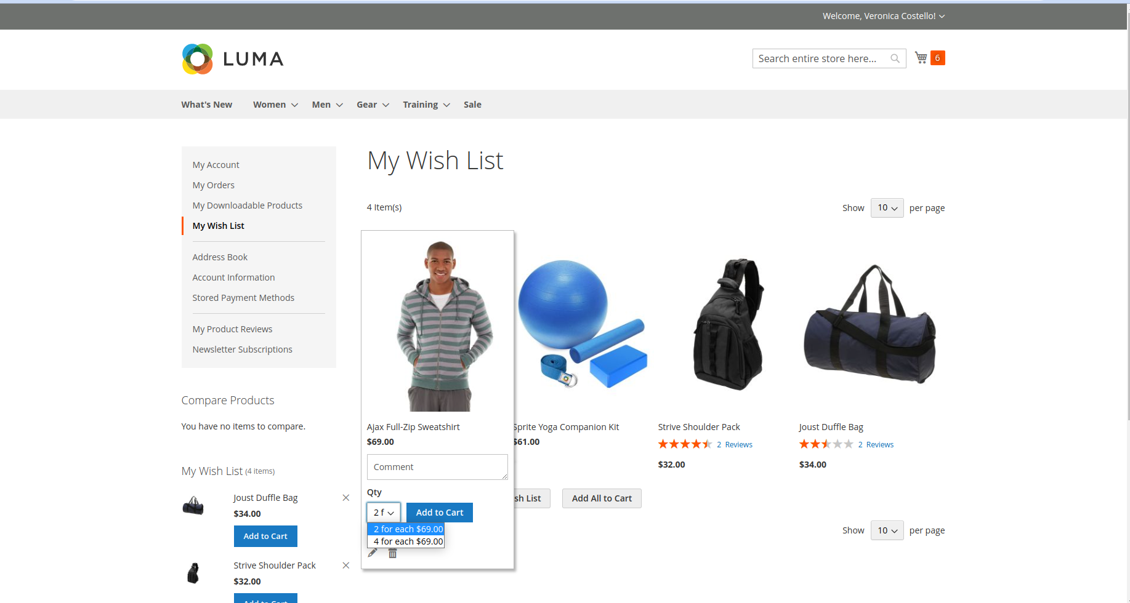I have select Dropdown Type ‘Custom Value’ and add Custom Value inputbox ‘1,4,6,9’ and save config.

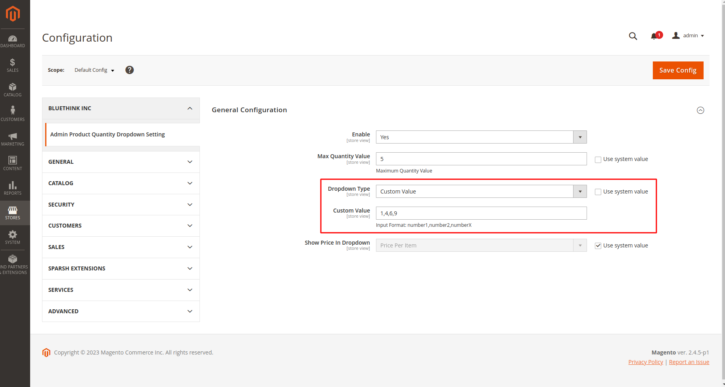

Product quantity dropdown look like this.

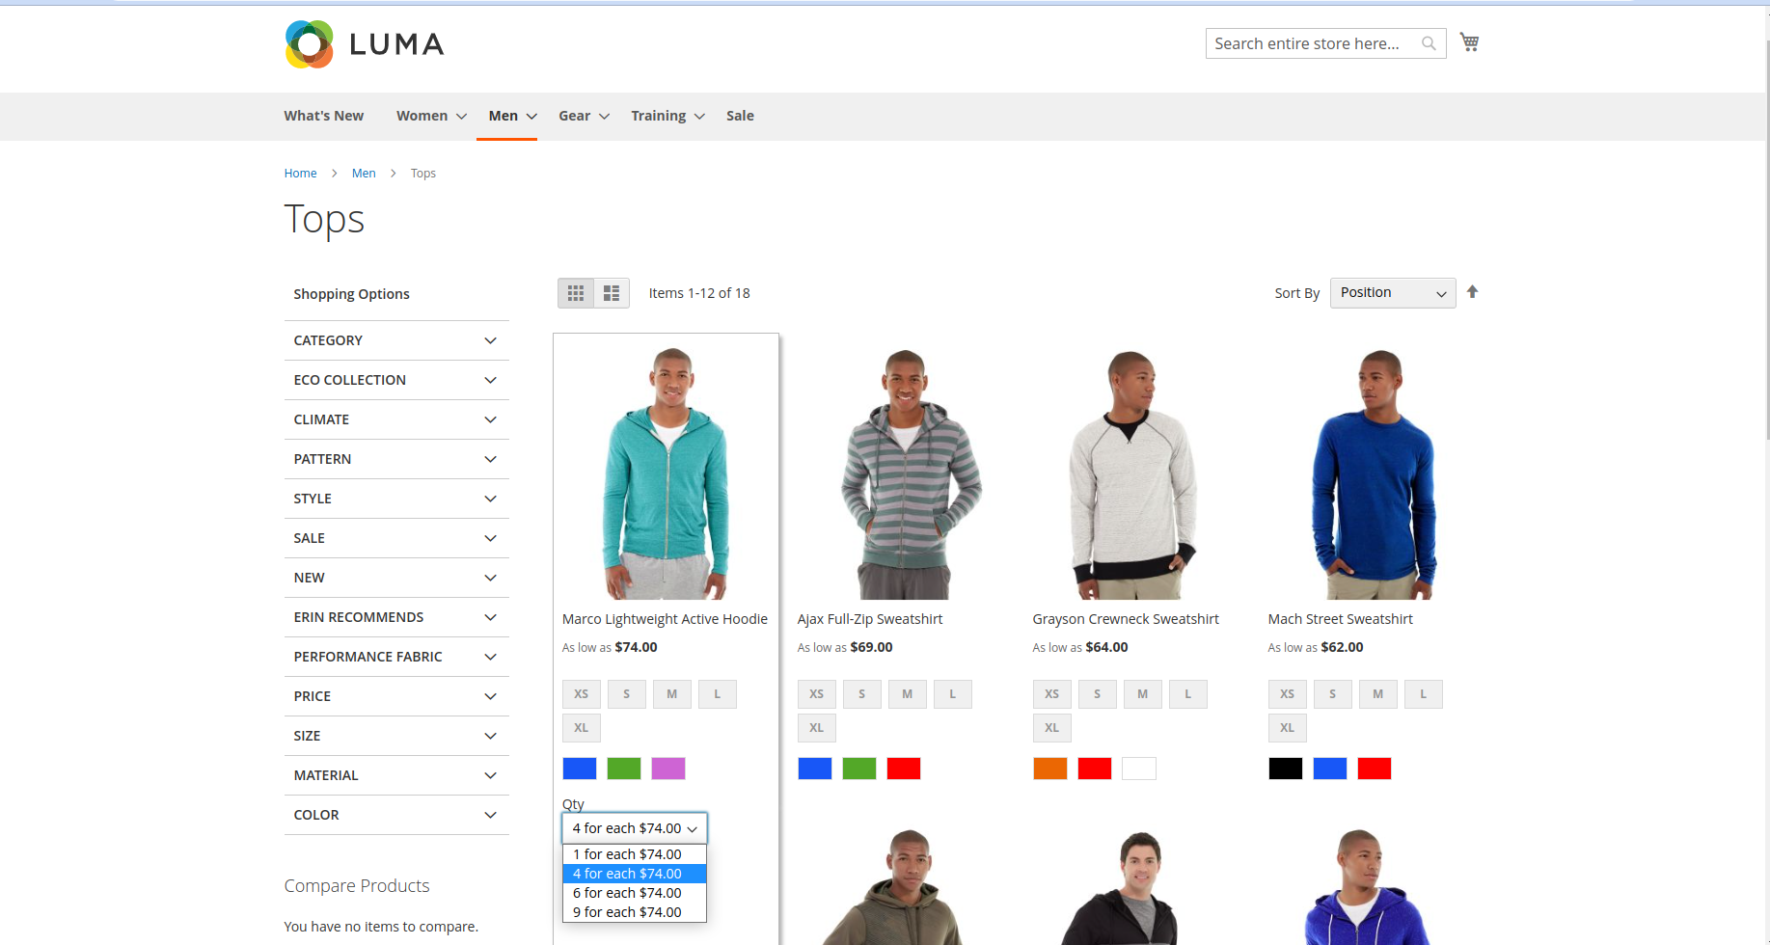

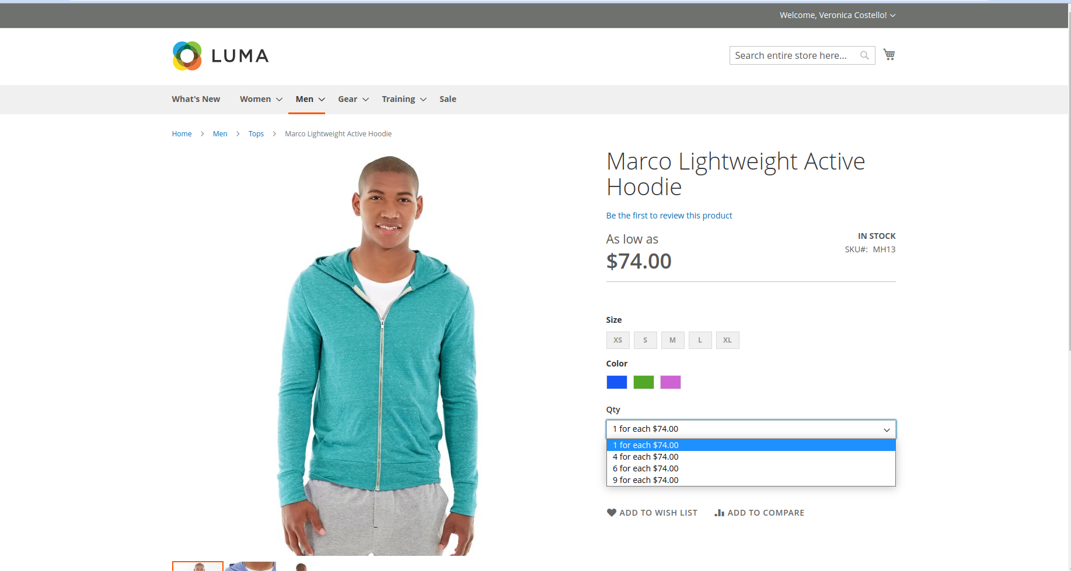

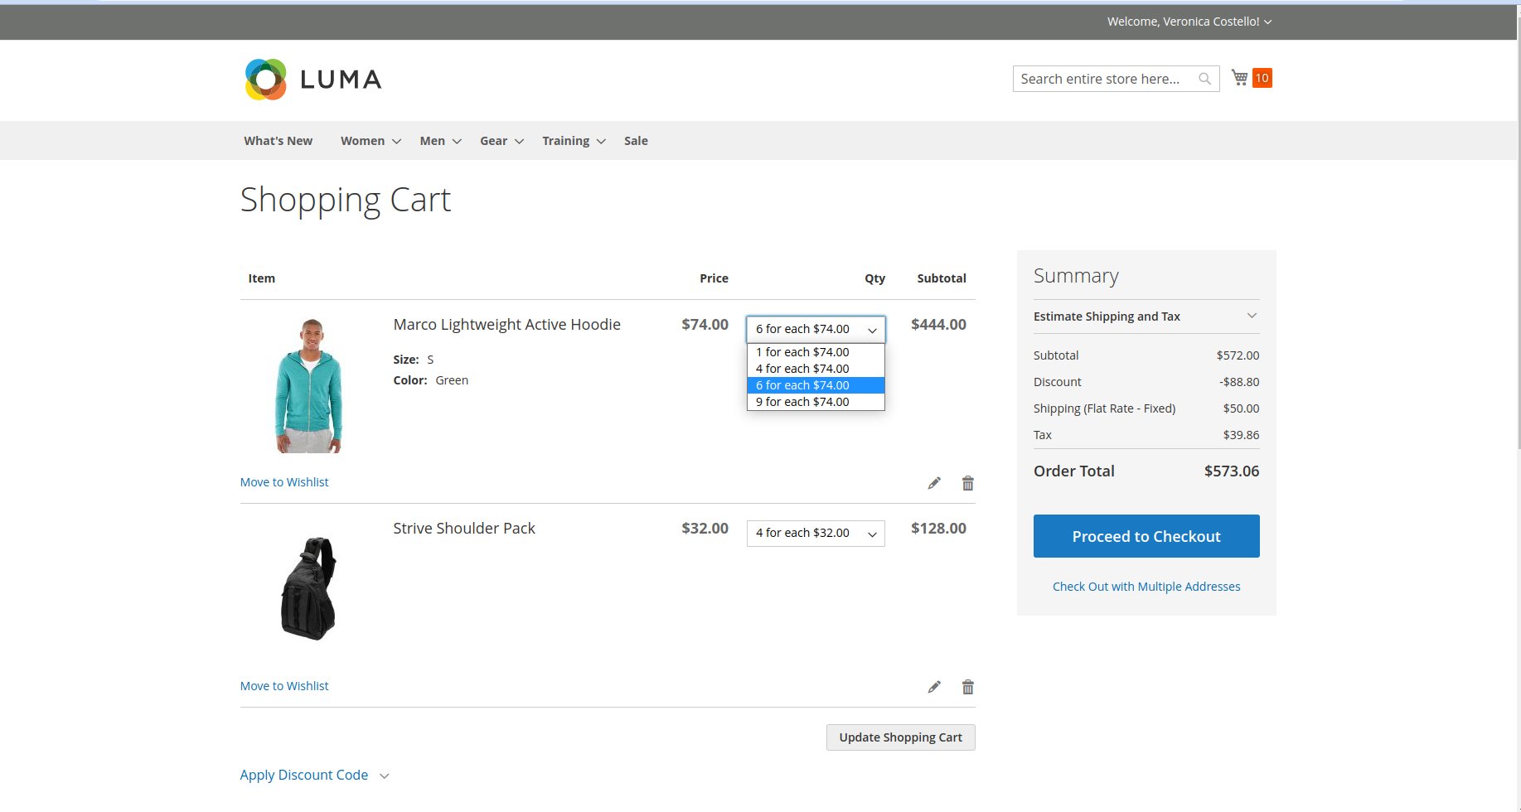

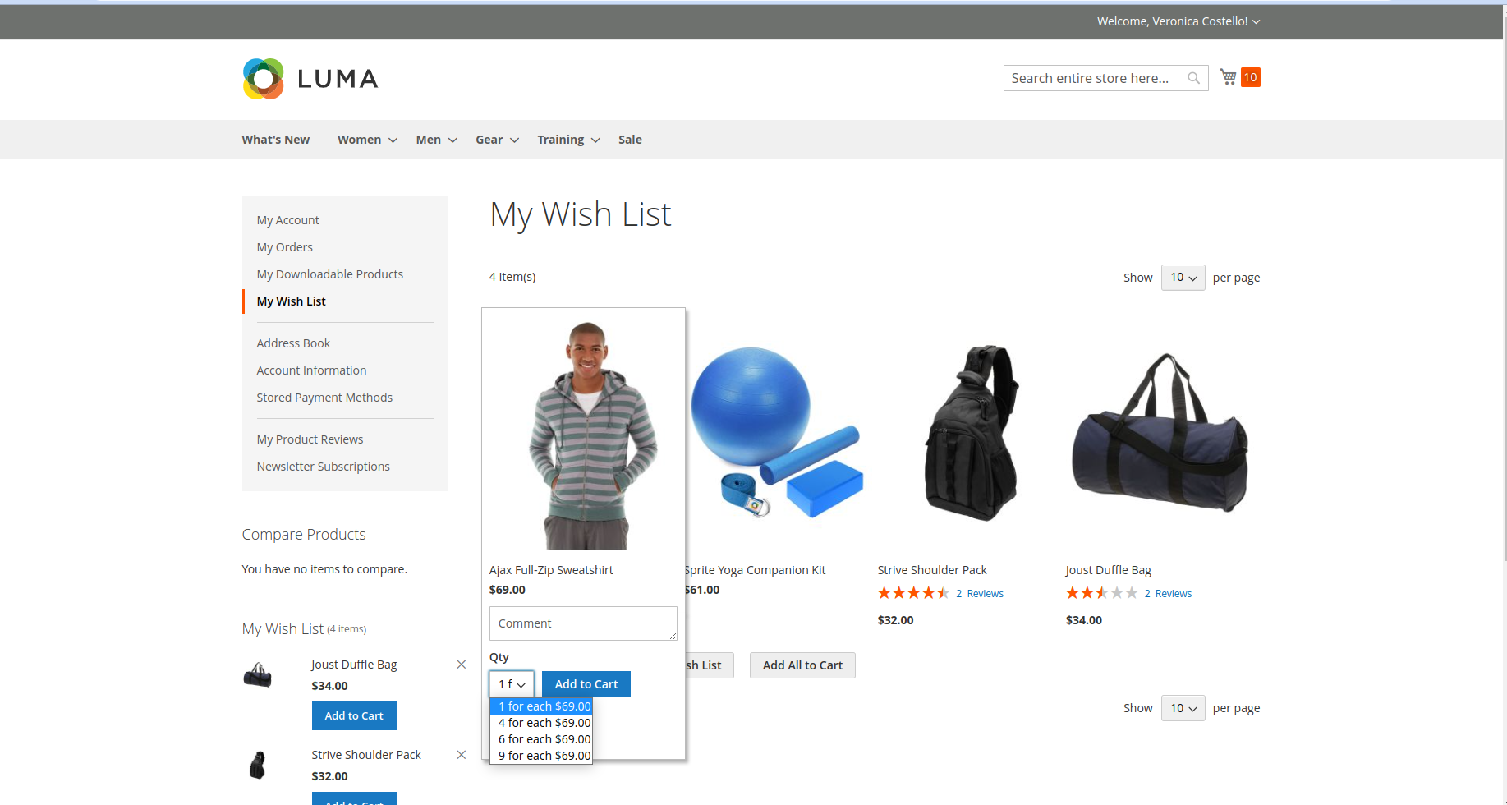

I have select option Show Price In Dropdown ‘Total Price’ and seve config.

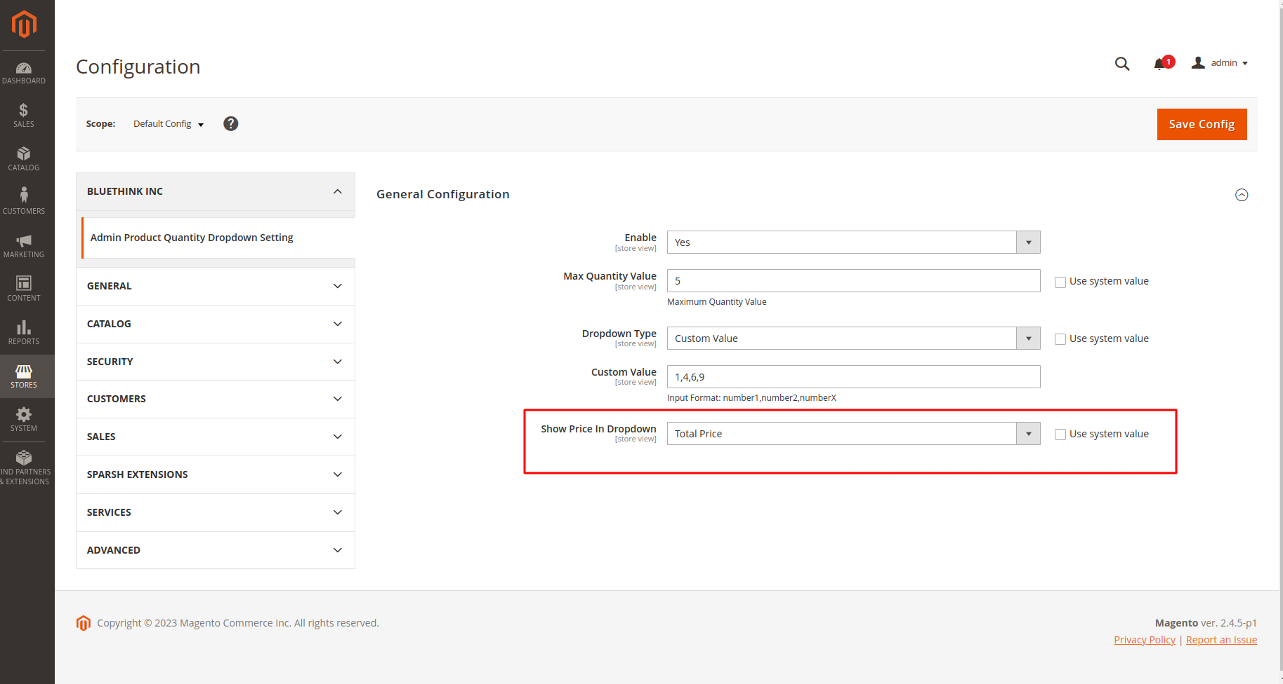

Product quantity dropdown look like this.

